

**PROJECT PROPOSAL**

**(TOUCH SWITCH DEVICE)**

**Section: B**

**Engineering Work Shop**

**Submitted By**

**Zia ul Islam (R.No:33)**

**Abdul Raheem (R: No: 27)**

**Ashfaq Ahmad (R.No:31)**

**Shah Husain (R.No:16)**

**Submitted to:**

**Engr Muhammad Noman**

**8 Jan, 2020**

**Department of Computer System Engineering**

**University of Engineering and Technology Peshawar**

**How to make a touch switch circuit.**

**INTRODUCTION:**

A touch sensor is a type of equipment that captures and records physical touch or embrace on a device and/or object. It enables a device or object to detect touch, typically by a human user or operator. A touch sensor may also be called a touch detector. This little and flexible circuit consist of a touch sensor and transistor with small buzzer or led as the output loud. Two touch sensor strips of metal are mounted side by side and connected to input of the circuit.

**Apparatus:**

* Buzzer or LED
* breadboard
* Resister (10kohm and 220kohm)
* Transistor (2n)
* Connecting wires
* Battery (3-9v)

**Buzzer:**

A **buzzer** or beeper is an audio signaling device, which may be mechanical, electromechanical, or piezoelectric (piezo for short). Typical uses of **buzzers** and beepers include alarm devices, timers, and confirmation of user input such as a mouse click or keystroke

**Working principle:**

They **work** by lowering the resistance between two pieces of metal. It is thus much simpler in construction compared to the capacitance **switch**. Placing one or two fingers across the plates achieves a turn on or closed state. Removing the finger(s) from the metal pieces turns the device off.

**Procedure:**

* Connect two transistors on breadboard.
* Connect the emitter of first transistor to the base of second transistor.
* Connect the emitter of second transistor to the ground.
* Now connect the emitter of first transistor to +ive rail with the help of 10 k ohm resister.
* Now connect the anode of LED with +ive rail.
* Now connect the collector of second transistor to cathode of LED with the help of 220 k ohm resister.
* Now place the one metal wire the collector of first transistor and second wire with the base of first transistor.
* Finally connect the +ive terminal of power supply with +ive rail and –ive terminal with –ive rail.
* The circuit is complete.

**Circuit diagram:**

[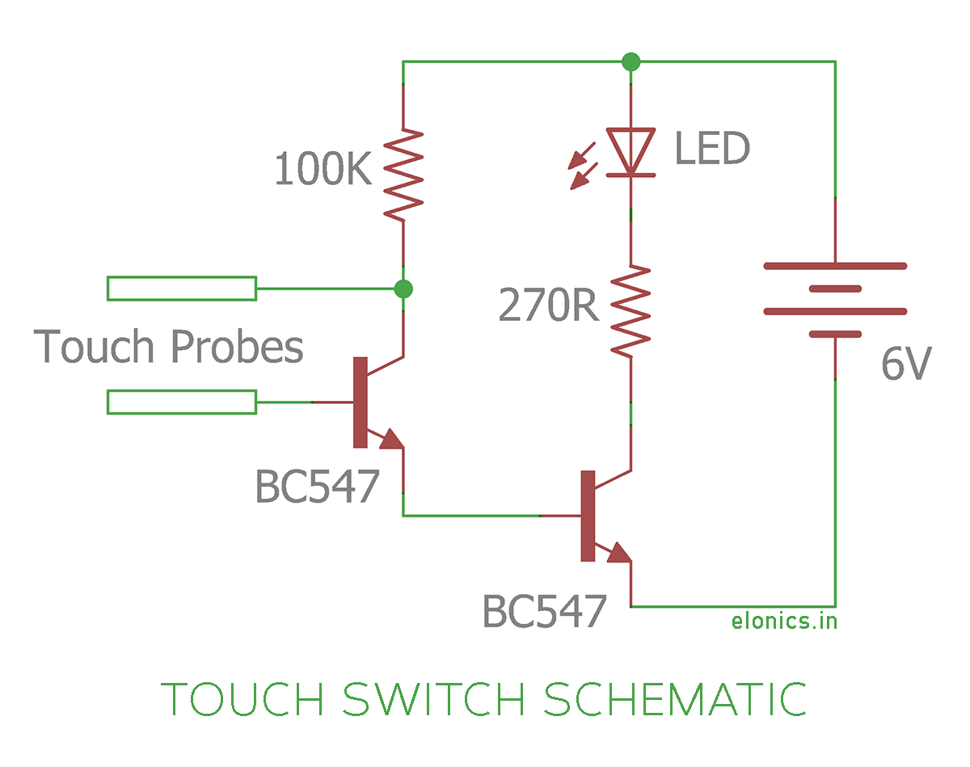](http://elonics.in/sites/default/files/inline-images/touch-switch-circuit-using-transistor-schematic.png)

**Working:**

The purpose of this project is to trigger/switch an LED with a simple touch. The skins resistance is about 600K-1M. So if you try building a circuit with just an LED, power supply and touch conductors, the LED doesn't glow. This is because; high skin's resistance prevents enough current to flow through the circuit. So the only option we have is to amplify the tiny current flowing through the skin to a magnitude enough for an LED to glow.

For that purpose, we have to use transistors. The circuit will also work with just one transistor, but the LED doesn't glow bright enough. So we have used two. Tiny electric current flows through the skin when the end touch conductors are touched. This tiny current is amplified in magnitude by the first and second transistors and it finally passes through the LED. Refer to the circuit diagram for better understanding.

**Application:**

* It is used in many lamps and wall switches that have a metal exterior as well as on public computer terminals.
* It can be used in touch-based blinking lights.
* It can be used to detect the electrostatic build up in a room.
* Touch switches is used for doorbells.
* It can be used to make touch-based buzzers.
* It is also used as a touch sensor.

**END**